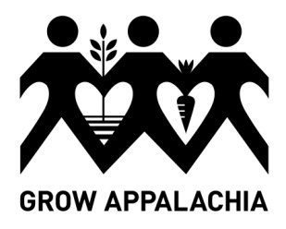 Grow Appalachia
Participant Application Appalachia-Science in the Public Interest

Grow Appalachia is dedicated to helping mountain families plant a healthy future for themselves and their communities by:
- Providing them with skills and resources to grow sustainable, nutritious food.
- Teaching them how to prepare and preserve food in a healthy way.
- Empowering them to share their knowledge in the community.
- Creating programs to provide food to elderly and disabled residents in need.
- Supporting local farmers markets to sell surplus food.

Participants will be required to:
- provide a site for a vegetable garden (or take on a Community Garden plot)
- have the soil tested (at Grow Appalachia expense)
- attend a minimum of three trainings (two workshops shall be required to receive materials: Food Preservation; Marketing and Selling Gardening Products),
- For home gardeners, participants will select (from summer internship schedule) one weekly education session in which participant will assist interns with hands-on learning of subject matter.
- For Community Gardeners, participants will attend the Community Garden construction and select three Community Garden Work Days.
- record and return monthly harvest records,
- provide updates to Project Coordinator,
- volunteer five (5) hours of time to the Grow Appalachia Garden Project.

Applicant Name: ____________________________________________ Age: ____________

Physical Address: ___________________________________________
___________________________________________
___________________________________________
Mailing Address (if different from above): ____________________________________
Telephone Number: ____________________________________
Email: _______________________________________________

Family Members in Household:

Name | Relationship to Applicant | Age

Do you have your own property for a garden site? YES NO
Do you need a Community Garden plot? YES NO

Have you ever had a family garden? YES NO

Does anyone receive public assistance in household? YES NO

If YES:
- How many years has it been producing? ___________________________
- What did you harvest?

Crop Type | Quantities (please specify rows or measured harvest – i.e. bushels, pecks, etc.)

- Did you ever sell from your garden? YES NO

- Did you ever give food away from your garden? YES NO

- What was your experience with a family garden in the past? Did you have problems? Please use the space below to tell us about your experience: (or use this space for any other comments you would like to make)

Applicant signature: _________________________________________________ Date: ________________

Return completed application by February 15th, 2014 to ASPI office at:
50 Lair St. Mt. Vernon, KY 40456
Contact project coordinator if you have questions at: Ph: 606-256-0077

